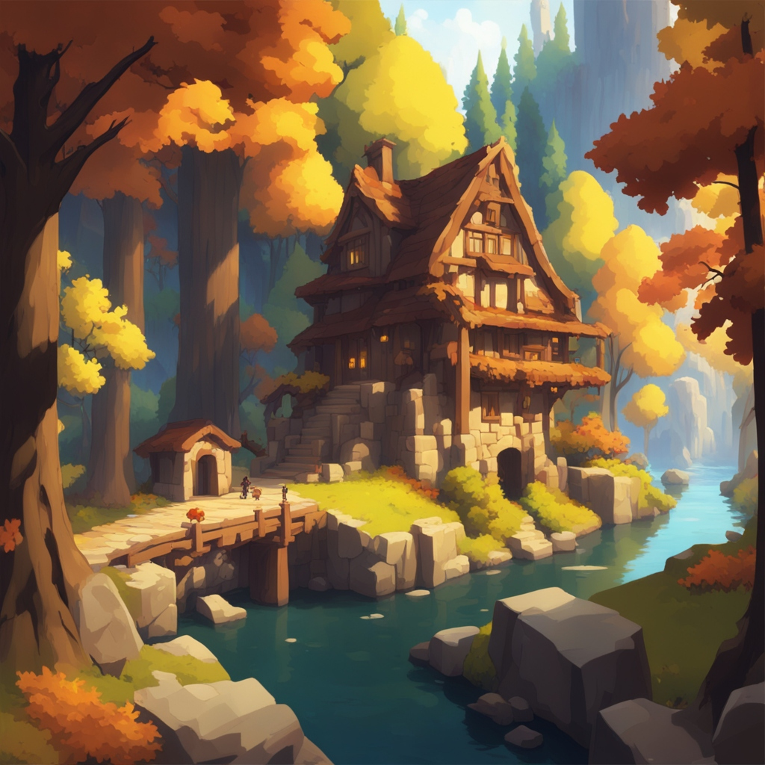

(image subject to change)

**The Little Things**

James Leung, Brice Tillman, Caitlyn Gustafson, Caleb Garza

**The Little things** Minecraft Mod

* For casual Minecraft players
* Who want a new experience playing Minecraft
* The Little things is a Mincraft Mod
* That adds a new biome to Minecraft
* Unlike Maple (an Existing maple themed modpack)
* Our product offers greater variation in gameplay and features that enhance creativity.

**Market Analysis**

**Base Game Info**

* Game: Minecraft
* Genre: Sandbox
* Player Base:166 Million active users in 2024 (<https://www.demandsage.com/minecraft-statistics/>)
* Modding Support: Supported by developers

**Reason to Mod**

Minecraft is one of the largest games with one of the largest and steady player base(<https://www.ign.com/articles/best-selling-video-games-of-all-time-grand-theft-auto-minecraft-tetris>, <https://newzoo.com/resources/rankings/top-20-pc-games>). Due to the long history some user may feel stagnant and may seek out outside mods for a fresh experience on a beloved game.

**Target Audience**

The base game has an average user base of 24 years old, with 15-21 year olds to make up 43% of the user base. Due to the relaxing nature of this mod we aim to target a large amount of players in this range.

**Market Competition**

Maple by skniro

* Focuses on a similar maple forest theme offering new biomes, items, and blocks.

MapleForest by stockieslad

* A simple modpack that adds 3 new maple themed biomes.

Both of these Modpacks offer a similar theme to our mod, but they lack the depth we aim to offer.

**Monetization Potential**

Posting your mod on modrinth and getting a certain amount of views on your mod page can lead to monetization. Modrinth will pay you for the ad revenue you produce on your mod’s listing and each download. The website portions off 75% of ad revenue to go to creators of the mods, from this each creator gets a portion from this depending on how active it is compared to all the other creators. If the product comes out bug free there is no continued cost, allowing this to be passive income.

**Marketing Strategy**

There are over 20000 mods overall on modrinth, 288 of which include the word biomes in the title or description. There is a lot of competition to get the word out. Popular method to advertise with small to little cost is to have fun “Let’s Plays” posted on YouTube (which can be another source of revenue from ads), mod trailers, social media outreach for updates, teaser or announcements and creating servers to let users test the mod

**Two Scenarios:**

1. Jack is a college student in Boston, learning about computer science. After having played minecraft for many years, he is bored with vanilla features and is looking for something new. He has decided that he would like to get together with his friends online and create a modpack with them to accomplish this task.   
    Right now, they are looking for mods that will bring a sense of newness to the game rather than something that changes the whole feel of it. They would like something that adds new items, biomes, and gameplay features. After scrolling through Modrinth for a while and adding mods that caught their attention, they stumbled upon our mod, “The Little Things.” After opening the game with their mods installed, they discovered two new biomes from our mod, the maple forest and the ruins. They enjoyed crafting new blocks, items, and features that came along with the mod, and they appreciated the new but still vanilla feel that came from downloading it. It was just what they needed to break up the monotony of the base game.

After their initial playthrough with “The Little Things,” they told their other friends about it so that if they wanted something similar they could download the same mod. Now, in the future they know that they will be more likely to add this mod to other modpacks, as its features were enjoyable and subtle enough to not create an entirely different feeling game.

1. Jill is a high schooler living in Seattle who enjoys creating aesthetic builds in minecraft in her free time. Since she’s very creative, she is always looking for new ways to use base game blocks to create new things. However, she sometimes just wants something completely new, which is why she occasionally frequents online mod websites to look for new blocks and decorative items.   
    After being recommended our mod from a youtube mod showcase, she went online to download it. She especially liked the maple tree biome that she thought would look really good as a backdrop for a new build. In addition, she liked the new wood color that the maple wood provided, and how cute the new mobs were. Jill also liked the new placeable decorative items, as they made it easy to add the clutter she liked to her builds. She quickly put together various fall-themed maple tree forest inspired builds and posted them on her small minecraft build instagram account. In the end she was extremely pleased with how cute the mod was and was certain to use it again for future builds.

Jill, while enjoying this mod greatly, was never much of a base game player and really only did building. While this was fine for the mod, it meant that she did not get the chance to explore the other things our mod had to offer, such as the ruins biome or the gameplay features we added.

**5 Stories:**

1. As a Minecraft player, I want to have access to a more diverse gameplay experience to break up the monotony of playing the same game over and over.
2. As a player of minecraft, I want to have more items and places to explore to gather more items to build with so I can create and experience new things within minecraft.
3. As a mod showcase youtuber, I want to look for new mods so that I can put them in my videos and recommend them to my followers.
4. As a minecraft mod creator, I want to explore and view other mods that have been created so that I can gather inspiration for my own mod making purposes.
5. As a minecraft builder, I want to look for mods with new blocks and decorative items that will give me greater ability to create builds without drastically changing the feel of the game.

**Functional Requirements:**

1. The user can generate and place new blocks with unique properties.
2. Players will experience a new biome, with unique elements.
3. Players can create new items with specific recipes.
4. Players will be able to interact with new mobs/npcs.
5. The players will find an interactive tutorial to guide them on the mod’s functionality

**Nonfunctional Requirements:**

1. The mod-pack should have minimal impact on the games overall performance, not introducing major bugs/game play issues and should not reduce the fps to lower than 30.
2. The mod should be compatible with the latest version of minecraft.
3. Documentation must be provided for installation and usage
4. Should have a functional UI that makes the mod more easily accessible/understandable for the player.
5. Minecraft and Mod should load within 10 seconds

<https://github.com/cqlebr/The-Little-Things>